REPORT

Drivers Training for Employment:
Since two years IBT has launched Free Four Wheeler Driving Training to our unemployed youths to create employment with the help of our well wishers. By grace of Allah up till now 92 candidates has completed their training and received driving licenses, most of them are employed as domestic drivers and few has gone abroad also. Highlight : Deniyath training is compulsory to trainers to become God fearing drivers.
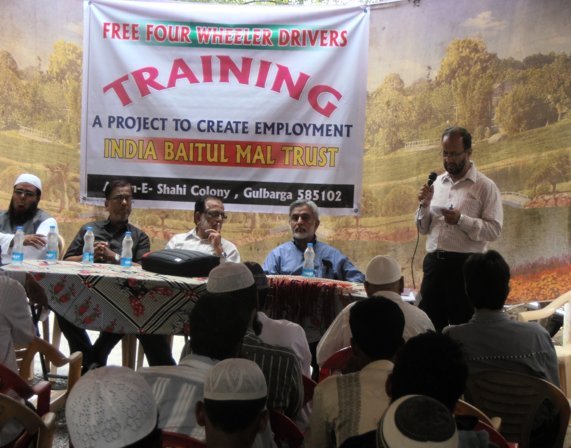
Drivers Training program to our unemployed youths

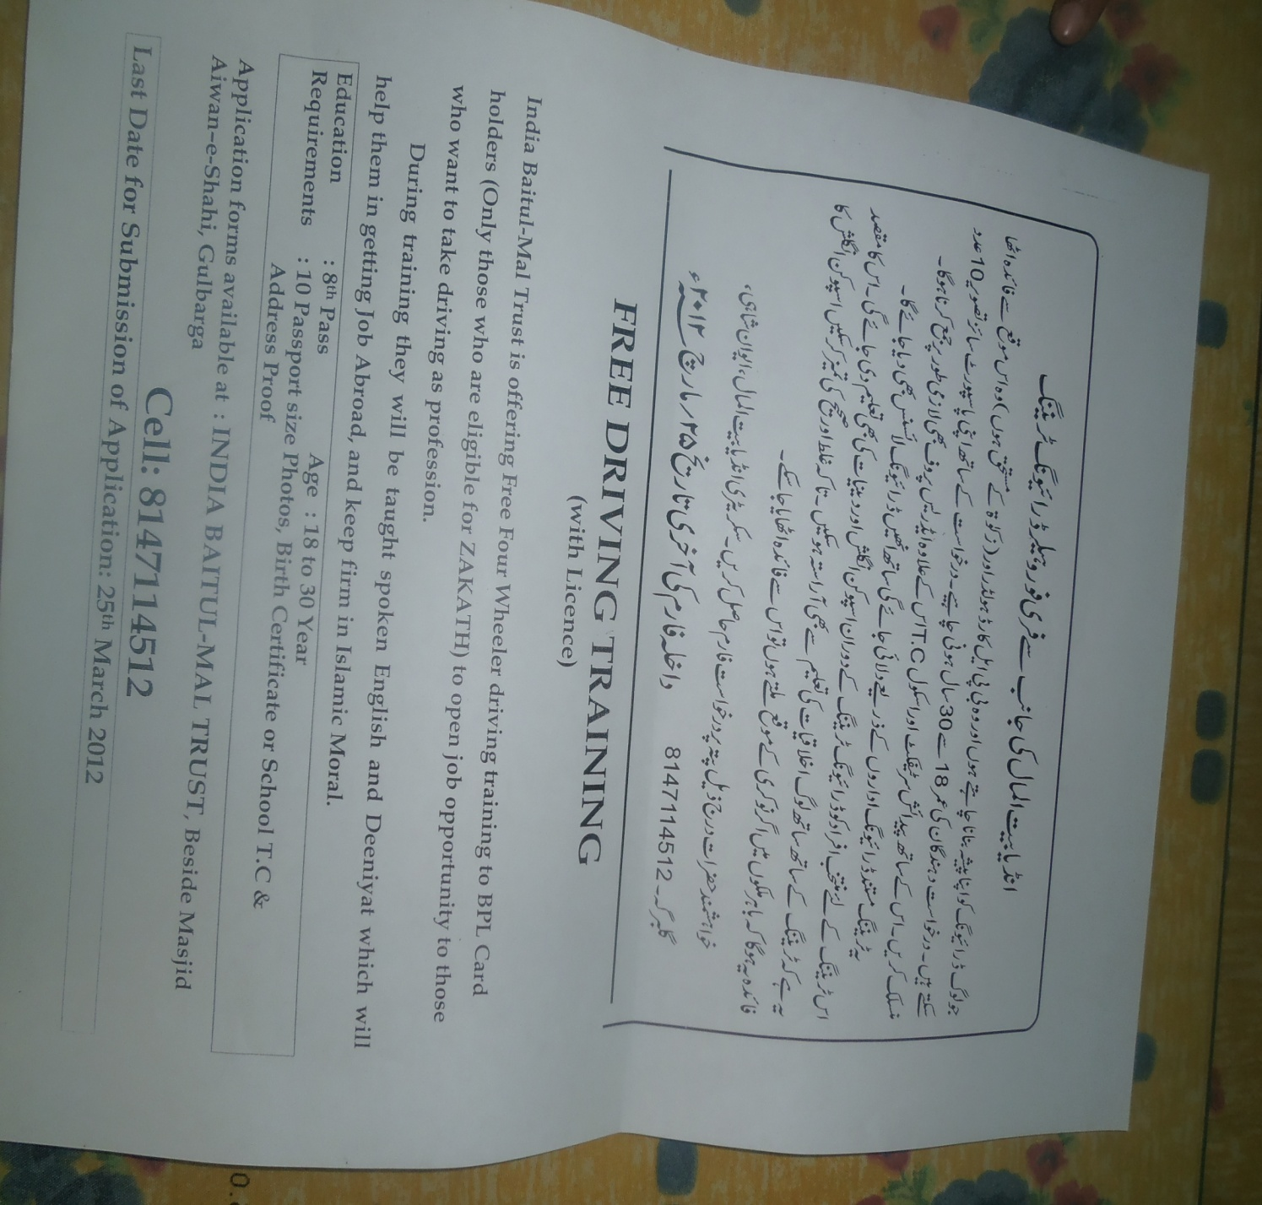

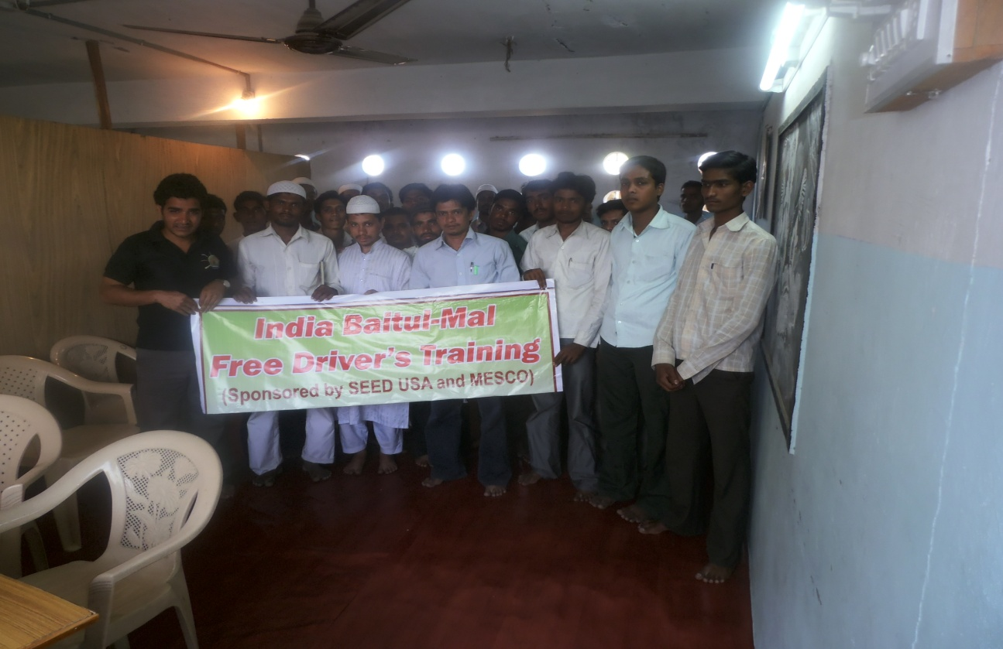

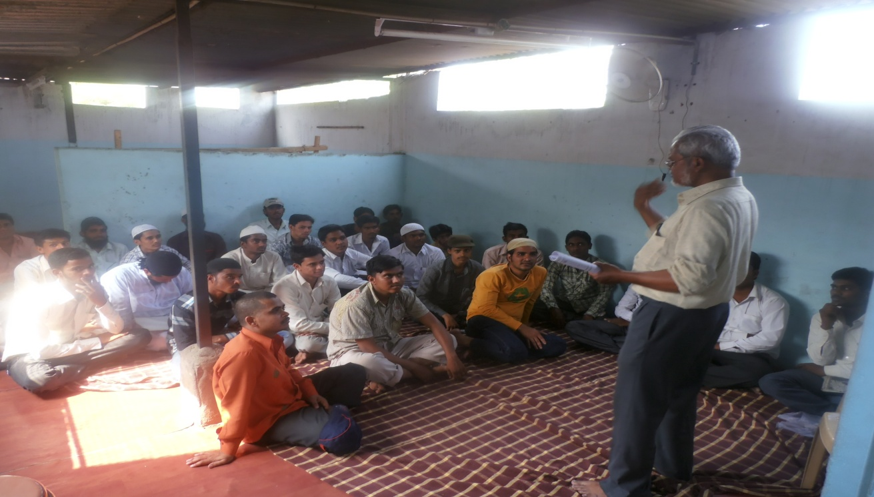
Deeniyat Training classes for drivers

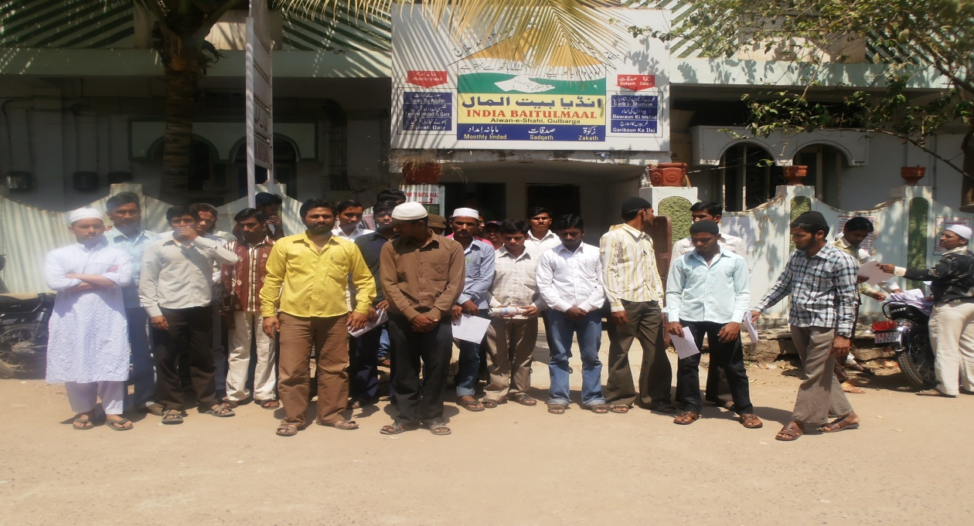

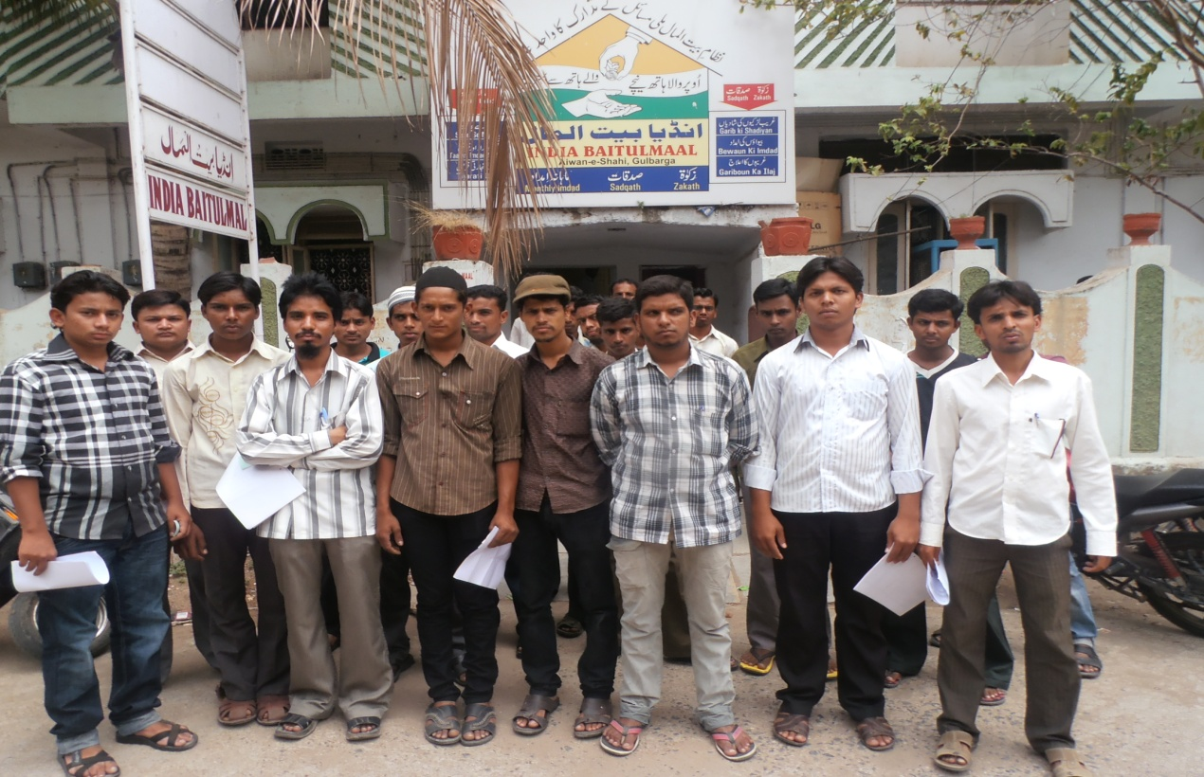

Date : 30 March 2012

Dear Mazher Bhai
Assalam Alaikum Wa Rahmatullah
You will be happy to hear 82 candidates has attended the Driving interview. We have selected 32 candidates who really deserve and want to accept driving as their profession. Inshallah from 1st April to 30th April Deeniyath and English classes will be conducted, after completion of this classes immediately driving classes will start. It is expected 5 to 7 candidates will miss the Deniyath classes or not sincere and interested will be dropped, the remaining 25 candidates will get the training in which extra 5 students expenses will be borne by IBT. I am sending the list of 32 students and their father occupation.
This project of yours has got lot of publicity in Gulbarga city, we have received and receiving lot of appreciation calls from people for this unique, fruitful and for introducing this project first time in Gulbarga.
We all Trustees of India Baitul Mal thank you and all your patners and pray Allah to reward all of you here and in hereafter Amin.
Thanks and regards

Mohd. Iqbal Ali
Secretary
IBT

DRIVERS TRAINING BY INDIA BAITUL-MAL (SPONSORED BY SEED) APRIL 2012
S.No | Name of Canditates | Form No. | Mobile | Address (Area) | Father Occupation
1 | Gulam Hassan s/o Md. Abdul | 2 | 9986663318 | MSK Mill | Petty Business
2 | Sajjad Ali s/o Khaja | 5 | 9632624585 | Tippu Sultan Chowk | Late
3 | Shirajuddin s/o Chanda Vali | 7 | 7899578626 | MSK Mill | Labour
4 | Altaf Ahmed s/o Ahmed Shareef | 11 | 9900854200 | Station Bazar | Const. Labour
5 | Mansoor Ahmed s/o Asrar Ahmed | 14 | 7411727833 | MSK Mill | Late
6 | Mohd. Ghouse Ali s/o A. Ghani | 19 | 9739751155 | MSK Mill | Helper
7 | Syed Ather Ali s/o Syed Babar Ali | 25 | 9611556328 | Millat Nagar (KCT) | Carpenter
8 | Mohd. Hussain s/o Md. Ibrahim | 32 | 9535032821 | Santrashwari | Late
9 | Akther Pasha s/o Saleem Miyan | 33 | 8867193500 | Muslim Sangh | Auto Driver
10 | Alam Khan s/o Abdullah Khan | 36 | 9740884489 | Hagarga Road | Carpenter
11 | Mohd. Ismail s/o Fathe Ahmed | 37 | 9901117408 | MSK Mill | Helper
12 | Abdul Razzak s/o Siddanna | 39 | 9880745098 | Mehboob Nagar RR | Barber
13 | Abubakr s/o Shrimanth | 40 | 9845308806 | Mehboob Nagar RR | Barber
14 | Md. Rafeeq Hassan s/o M.Abid H. | 42 | 9019325393 | Naya Mohalla | Private Service
15 | Azam Baba s/o Sardar Miyan | 43 | 8880504826 | Naya Mohalla | Qureshi
16 | Mohd. Muqtar s/o Fateh Ahmed | 44 | 8431842199 | MSK Mill | Petty Business
17 | Shaikh Javeed s/o Abdul Rahim | 45 | 9739272757 | Mominpura | Late
18 | Md. Fayyaz Ahmed s/o Md.Rasheed | 46 | 9902614332 | Muslim Sangh | Labour
19 | Mohd. Anwar s/o M. Taher Miyan | 47 | 9902087581 | MSK Mill | Mouzzan
20 | Syed Patel s/o Md. Patel | 50 | 9972270780 | MSK Mill | Salesman
21 | Mohd. Haroon Rashed s/o Jeelani | 52 | 9972359864 | Bilalabad | Painter
22 | Rasheed Sab s/o Usman Sab | 53 | 9740891607 | MSK Mill | Agriculture
23 | Syed Ghouse s/o Khaleel Ahmed | 56 | 9901543026 | Tippu Sultan Chowk | Late
24 | Zakir Hussain s/o Abdul Hameed | 57 | 9663126437 | Tippu Sultan Chowk | Labour
25 | Md. Mustafa s/o Ghouse Mohiuddin | 58 | 8123070181 | Mehboob Nagar RR | Electrician
26 | Mohd. Sarwar s/o Md.Inayath Ali | 59 | 9036394478 | Mehboob Nagar RR | Electrician
27 | Ayatullah Sarmast s/o Sarmasth | 60 | 9845678648 | Tippu Sultan Chowk | Hackwer
28 | Immauddin Shah s/o Qasim Ali | 62 | 9141771040 | Shabazar Naka | Mouzzan
29 | Md. Salahuddin s/o Md. Allauddin | 63 | 9632019611 | Roza | Driver
30 | Hussain Sab s/o Baba Miyan | 64 | 8792318200 | Zafrabad | Labour
31 | Lateef Sab s/o Meera Sab | 66 | 9731771388 | Zafrabad | Labour
32 | Shoaibuddin s/o Moinuddin | 73 | 8867328068 | Zubair Colony | Late

